Feasibility of eliminating and replacing single-use products in Hotel industry

Prepared for American Hotel and Lodging Association (AHLA)

Table of Contents
Summary..........................................................................................................................................3
Introduction..................................................................................................................................4-5
Overview..............................................................................................................................4
Effects…...........................................................................................................................4-5
Benefits................................................................................................................................5
Key Problems...................................................................................................................................6
Environmental issues...........................................................................................................6
Description...............................................................................................................6
Improvements..........................................................................................................6
Economic.............................................................................................................................7
Alternatives.............................................................................................................6
Cost........................................................................................................................6
Social..............................................................................................................................7-8
Education…..........................................................................................................7
Incentives…………………....................................................................................8
Benefits.......................................................................................................................................9-10
Positive Environmental Impact …......................................................................................9
Sustainable.........................................................................................................................10
Conclusion.....................................................................................................................................10
References......................................................................................................................................11
Appendix........................................................................................................................................12
Figures and Tables
Graph 1. Global Plastic Waste by Disposables
Graph 2. Global Plastic Production from1950 to 2015
Map 1. Plastic Impact on World’s Oceans
Summary
The purpose of this study is to determine the feasibility of installing a mandatory standard for hotel companies to limit the amount of single use products and plastics across the industry. These regulations will help the environmental crisis that these single use products are increasing. There are countless benefits that mandatory rules in hotels will help; starting from the reduction of plastic waste while supporting environmental friendly products. Standards enforced and controlled by the AHLA of the use of single-use products and plastics,will show staggering evidence to make the initiative a model for global hotel associations to follow. Since, the association inspires other Westen and Eastern countries to strive for. There were several distinctive initiatives by numerous global hotel companies to help control the production and consumption of plastics. These initiatives have been at the individual level of each company and certain locations of resorts that have an impact on the issue is not notable. Whereas the proposed mandated regulations will create a significant impact on the waste from the hotel industry. There have been many non-profit and small organizations that are available to recycle products like soap bars and creating alternatives for plastics in toiletries. The main purpose of this report is to determine the feasibility and reliability of the formation of required standards for hotels that would regulate the use of plastic single-use waste. In order to assess the feasibility of these rules, it needs to fulfill these terms: capability of hotel companies following, access to alternative and eco-friendly products, and financial soundness. The research suggests that the enforcement from AHLA to regulate the usage of plastics products is . It is clear that even though the AHLA only has jurisdiction over hotel companies that are members, if members follow and uphold the guidelines there will be a significant impact on the industry standards and in turn on the environmental plastic crisis. More countries would take the opportunity and responsibility of providing waste management techniques to the world
Introduction
Overview
The following is a proposal of a feasibility report for how the hotel industry creates crucial guidelines of replacements of single-use products that hotels must follow as well as an incentive for companies that exceed standards with awards and marketing promotions. This proposal will create not only new environmental standards for hotels of all venues but make a path for a cleaner future. Exploring the problem with specific criteria that must be answered and followed before the proposed solution can be completed will be explained in the feasibility. In the following sections the need and benefits for the report as well as an outline, schedule, and associated costs will all be addressed in the feasibility report.

Single-Use and Plastic Waste

Benefits
Many significant benefits can come from the proposed feasibility report. Hotel plastic use is beneficial because they impact the effects of global plastic intake; providing disposable products at mass scope. First, the report will cover in-depth research on incentives and alternatives associated with replacing plastics as well as cost points. This data will mainly come from articles recently put out by G.R.E.E.N Hospitality, Hospitality Insights, as well as TUI Group that offer a crucial look at how this proposal could impact by providing Plastic reduction guidelines for hotels. Next, it can put quantitative data by tracking the population of plastic waste and how many hotels could put new standards in place

Key Problems
Environmental Issues
Description and Improvements
The rising rate of pollution especially of plastic, is one of concern. A study shows how moving towards a sustainable future slowly in industries that within the next 10 years we will see a major decrease in pollution and increase in global wellbeing. Mandating standards of replacing single-use plastics in the hotel industry may be economically costly at first but will pay off with being sustainable in the long term, and improve occupancies as the public shifts toward eco-conscious tourism. Eliminating plastic and single-use waste in hotels will be a major step to move towards a new start to get our planet back on track.
Economic
There are several financial factors that go into removing plastics and single-use waste from hotels in the US and globally. There are three main financial points to focus on. The first being sustainable product replacements. Plastics are cheap but renewables can be more expensive. The price mainly depends on the____. If the American Hotel and Lodging Association (AHLA) is willing to enforce new guidelines of no plastic or single-use waste like soaps and cups then other countries' hotels and lodging will follow. Another financial factor is the_____.

Social

Figure 1., Below, displays the
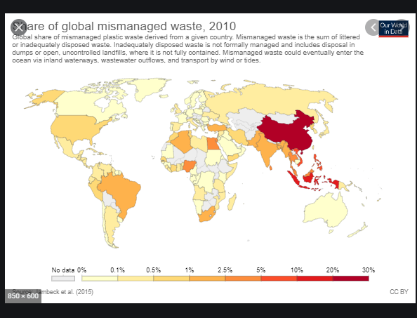
(Figure 1.)

Benefits
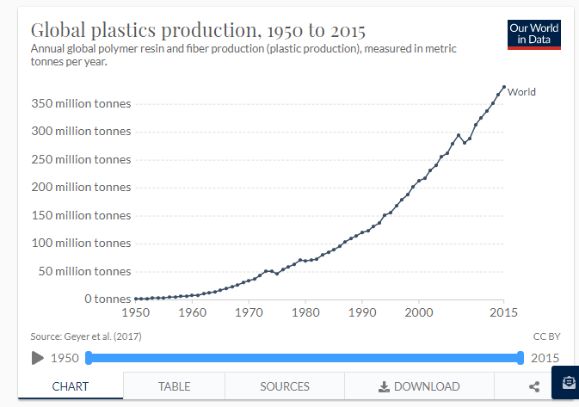
(Figure 2.)

Positive Environmental Impacts

Sustainable

Conclusion
This proposal gave a brief explanation of the hotel industry's increasing epidemic of single-use waste and proved the need for the new and enforced guidelines to help solve this problem. The benefits will be reaped for generations to come.
References
1.Davis, Ben. “Plastic: What Can the Hospitality Industry Do to Tackle the Problem of Plastic Waste?” GREEN Hospitality, 17 Apr. 2019, https://www.greenhospitality.io/post/plastic-what-can-the-hospitality-industry-do-to-tackle-the-problem-of-plastic-waste
2.higginho. “The Rise of Sustainable Tourism.” GREEN Hospitality, 4 Oct. 2019, https://www.greenhospitality.io/post/the-rise-of-sustainable-tourism .
3.https://www.tuigroup.com/damfiles/default/downloads/plastic_reduction_guide.pdf-2f4f4f0e2278382fcd50d9a530985b84.pdf
4. The plastic problem: Phasing out single-use toiletries in hotels. (2020, March 13). Hotelmanagement. https://www.hotelmanagement-network.com/features/single-use-plastic-toiletries-hotels/
5. Martin, G. (n.d.). California bans single-use plastics in hotel rooms. Forbes. Retrieved July 13, 2020, from https://www.forbes.com/sites/grantmartin/2019/10/13/california-bans-single-use-plastics-in-hotel-rooms/
6. Going plastic-free: Hotels and airlines reducing plastic use. (n.d.). Retrieved July 10, 2020, from https://hospitalityinsights.ehl.edu/hotels-single-use-plastics-ban
7. The hospitality industry is at the forefront of tackling the excessive use of plastic and technology could pitch with a few alternatives. (n.d.). HotelierIndia. Retrieved July 13, 2020, from https://www.hotelierindia.com/business/8596-the-hospitality-industry-is-at-the-forefront-of-tackling-the-excessive-use-of-plastic-and-technology-could-pitch
8. (2020). Who We Are. Retrieved August 02, 2020, from https://www.ahla.com/who-we-are

Appendix
Figure 1- Global Plastic Waste by Disposal . Map
Figure 2 -Global Plastic Production from 1950 to 2015 Graph
Plastic Impact on World's Oceans Map
